Question 1: Find out the mail servers of the following domain :

• Ibm.com

• Wipro.com

Using nslookup command

[WWW.IBM.COM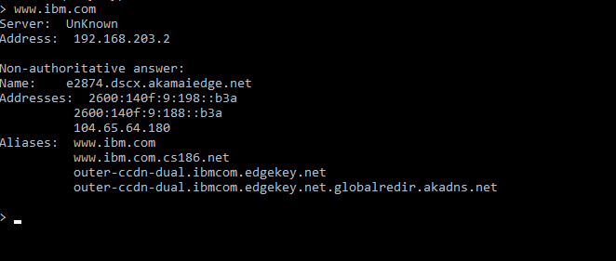](http://WWW.IBM.COM)

www.wipro.com

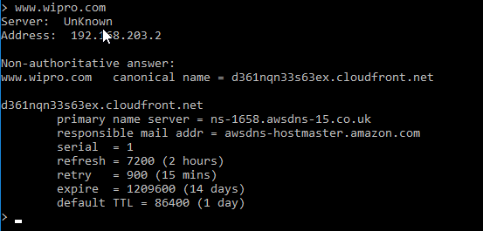

Question 2

FInd the location,where these email servers are hosted

> Using **Set type=mx command**

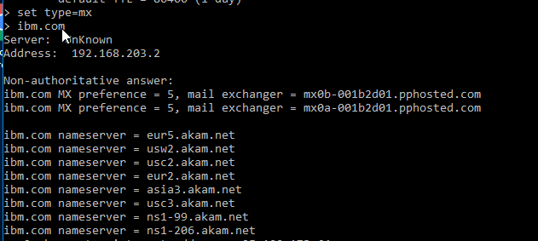

**Question 3**

**Scan and find out port numbers open 203.163.246.23.**

**Using nmap -Pn -sS -v -p- 203.163.246.23 command**

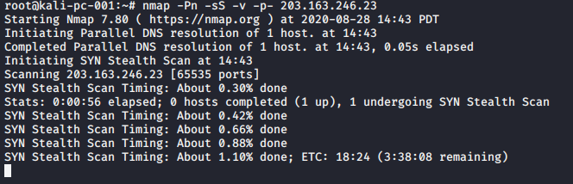

**Question 4:**

**Install nessus in a VM and scan your laptop/desktop for CVE.**